Recruiting and Operations Improvement
This document describes the current (as of June 2026) recruiting process and operations.
The intention is to make the overall process more effective.
On Discord there is a closed channel called “Recruiting” only visible to admins and the recruiting role.

Recruitment Strategy
The recruitment strategy of ReduceCO2Now is quite special.
We do not hold interviews any more, we invite people to join us in meetings and start contributing.
This has several reasons:
- We have done a lot of interviews in the past, but the retention rate was very low. Only very few people actually started to work for the project and stay on.
- Job Interviews are scientifically proven to be a very poor judgement of future work.
- We do not need interviews to decided who can join the project. We would like to have everybody join and contribute. We want to find the right job for them.
- Job Interviews are a Marketing tool of sorts for us. We use it to convince people to join the project.

Recruiting Process June 2026
Currently we are using LinkedIn Recruiting tool in the free (unpaid) version.

Posting Job Offers on LinkedIn
- Every day one Job offer is placed.
  - The job offer is in the category Volunteer
  - The job offer includes the text “You understand that this role is voluntary and unpaid?”
  - The title of the job offer is changed for each day.
  - Recurring jobs are: Software Developer, Software Engineer, Team Assistant, Graphic designer, Social media Expert etc.
  - The content of the Job offer is largely the same for all offers.
    - Only the line “Action: Support the project especially in the area of social media” is changed accordingly.
- Each job offer contains 4 questions rated as essential.
  - Are you comfortable working in a remote setting? (YES)
  - Do you understand that this role is voluntary and unpaid (YES)
  - What is your level of proficiency in English (Professional)
  - How much time would you be willing to work per week (>=10)
- Each job contains at 1-2 question for the specific job rated as essential
  - How many years of work experience do you have with social media (alternative software development, game development etc.)
  - How many apps have you developed?
- Each job offer contains 1-2 non-essential questions.
  - Can you start urgently?
  - Do you have a Discord Account?
- After the job offer is published no further actions are taken immediately.
  - After ca. 6 hours or if more than 10 applicants have applied, the job is posted by Thomas “We are hiring….” - This is done to give people who are not a connection yet the chance to apply first.
  - We found that a lot of people apply several times.
- After 10 applications LinkedIn is not showing the job offer actively in searches! Only people who have bookmarked it can apply.
- After 26 applications LinkedIn does not accept any more applications.

Response to applications
Usually between 5 and 26 applications arrive for each job offer (which is open one day max).
- Applications are screened and categorized:
  - Good fit - all essential questions answered correctly
  - Maybe - some essential questions are not satisfactory
  - Not a fit -> The question “Do you understand that this role is voluntary and unpaid” is answered with No.
- All good and maybe applicants are responded to with a message including their name and full text (see below).
- All Not a fit applicants get a shortened message.
- If a person already has applied before, then the response could be
  - The standard message (see below)
  - A short message “Join the Discord” or “Did you join Discord”
  - For repeated applications “Please join a meeting”
When applicants respond with an acknowledgment message and write they will join Discord, read the material and join a meeting, they will receive a “Thank you” message

When applicants ask specific questions they will be answered.

When applicants ask for more details about the project, conditions of the job, etc. before they are willing to goto Discord, they will get the “response to query” message with more detailed information (see below). That message uses links to LinkedIn resource pages, and gives the Discord invitation link again.

Results of the Application process
In general 10-20 new applications are received per day. Some people apply numerous times and do not make it to the server or to a meeting.
About estimated half of the people with an invitation actually join the discord server.
This is a screenshot from 17.6.26 showing invitations and total members.
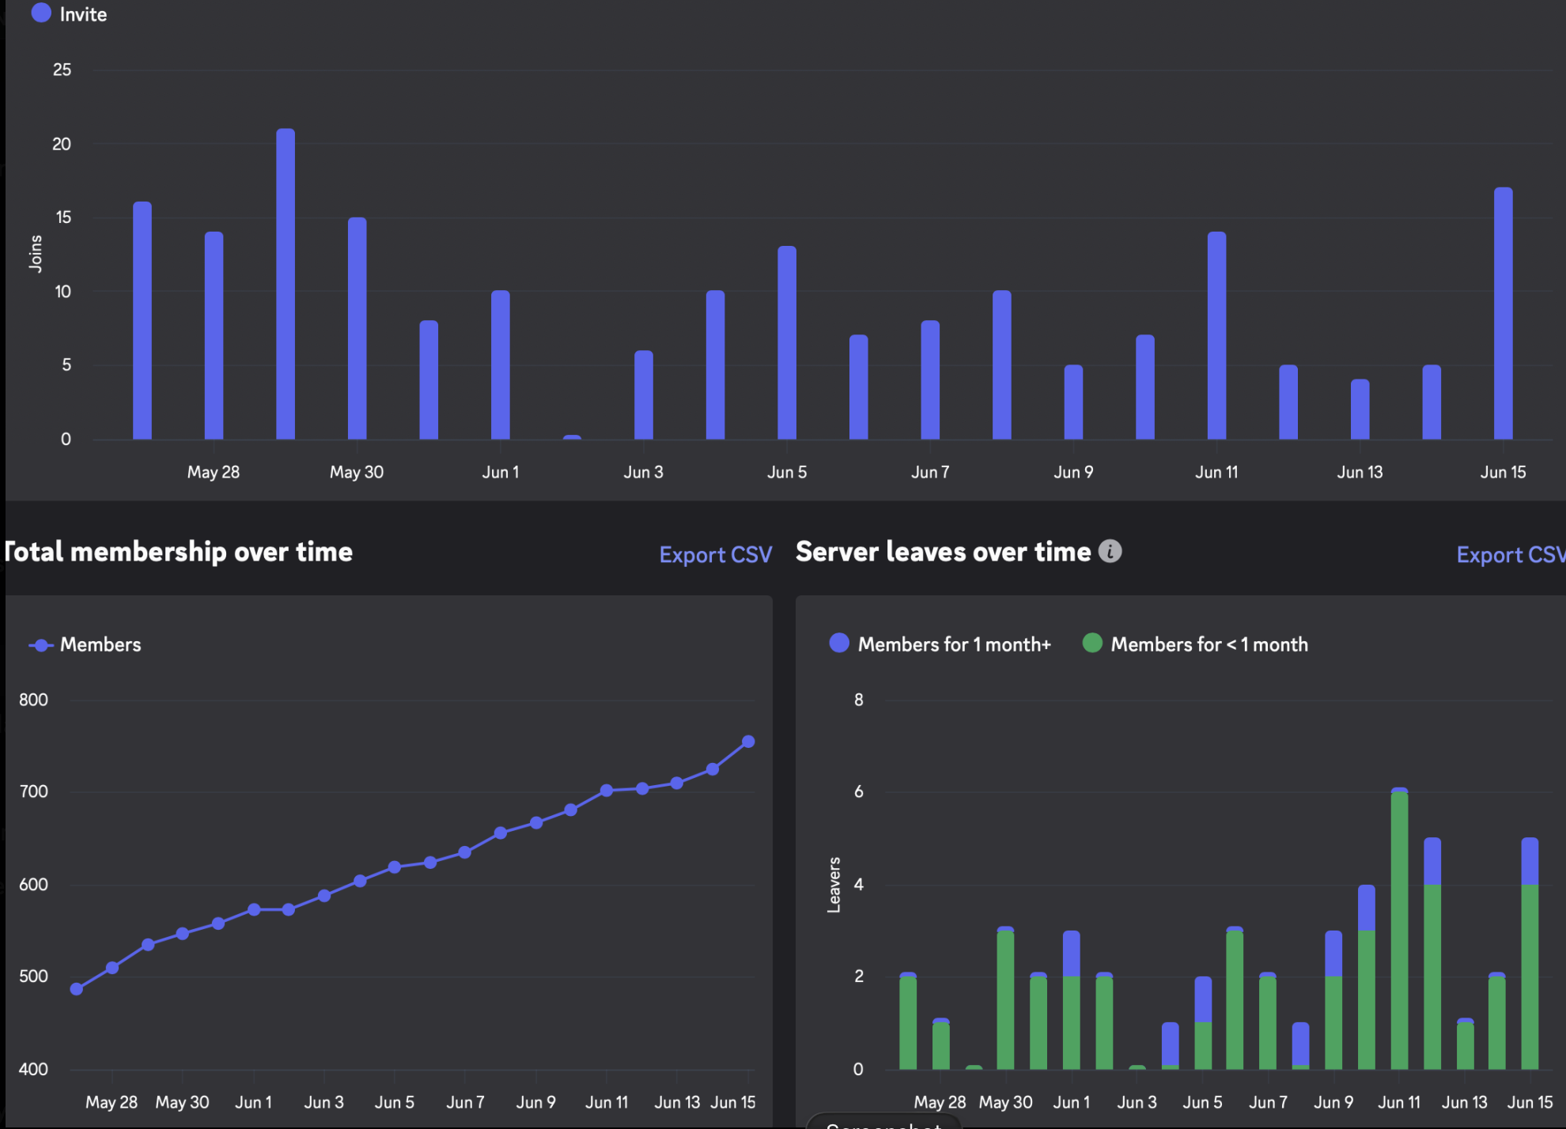

The Mystery
Even though 10-20 people apply (also on weekends) about half join the server.
A certain part (ca. xx%) make a self introduction on the #introduce-yourself channel.
But very few people actually make it to a meeting.
In the past we did not send out so many invitations as we were afraid to handle all the new people, but actually 0-1 person arrive in the morning meeting.

The Mission: Improve Effectiveness of the process
The task is to increase the effectiveness of the recruitment process.

To do that
- Find out why only few people make it into a meeting?
- What do they need to be motivated engaged?
- Improve the onboarding experience.
- Interview new people and ask them about their experience.

Right now one assumption is that people do not find out what they should do, might be to complicated.

So one of the things to do is to setup the Discord server good enough for people to overcome the problems.

The current strategy is based on quantity. One week is like this:
- Post at least 7 job offers.
- Receive about ca. 100 new applications
- Invite ca. 100 new applicants to join discord
- Get ca. 70 new members on discord each week
- Have about 7 new members join a meeting

Actions
- Make a table of all job offers and how many applied to which job. We want to find out what kind of job titles work best.
  - Some job titles got more applications then other. In the past job offers stayed open longer until > 20 applicant (max 26) were received.
  - Since June Job offers are open max 24 hours. Sometimes they are filled less time.
- Make a table of how many people join the Discord server. Current estimate is ca. 10 people per day join. We want to know what is the percentage of applicants who actually arrive
  - Until mid of June old applicants were invited to join again. So the figures before mid June might be to high. Right now (26.6.26) only the people from LinkedIn could arrive
- Make a table of how many people make a self introduction on the server per day.
- Change the invitation link used on social media posts. Discord tracks how many people arrive with an invitation link. Currently the links are created to last “forever”. So we can not distinguish between applicants and people coming from the website.
  - The default invitation is to the #Welcome Channel. It seems impossible to generate a second invitation link to the same channel with the same setting (unlimited number of uses & unlimited time).
- Find out how someone else can manage the job posting (and not only Thomas)
  - E.g. using Super Admin Feature?
- Find out what motivates people to work for the project
  - What is in it for you?
    - Learn about climate change from experts with in depth knowledge
    - Work in a complex, international project with all kinds of inter-cultural challenges
    - Have something on your CV when you are not employed
    - Get a letter of recommendation after at least xx weeks of successful participation
    - Get a recommendation on LinkedIn
    - Have ReduceCO2Now as an employer in your LinkedIn profile
    - Improve what you do
    - Use it as a showcase of your work, e.g. in design or social media show your posts.
    - Learn how to do agile project management from experienced project manager of Billion Euro sized projects
    - Learn how to develop software from a system engineering expert of highly complex aviation software projects.
    - What else????
- Find out what problem people have joining discord. Do a presentation about the most important tweaks: RCN How to use Discord.pptx
- Do a presentation about what we do: ReduceCO2Now - The Project
- Do a presentation about the climate change subject Global Warming - Climate Change - Solutions (V2.0).pptx
- Put all the presentation slides directly to discord to make access easier.
- Make a welcome video
- Make an onboarding video
- Make a Discord video
- Send a direct message to everyone on the server and invite them to join a project meeting and start participating.
- We are going to track now when someone joins a meeting by giving the role “meeting”
- We are going to track who is actively participating by giving the “active” role.
- We are also making minutes of meeting marking the persons in the meeting with @ and their username

Appendix.

Job Offer Text
The current Job Offer Text is as follows:
Social Media Engagement Manager
Stop scrolling. Start creating. Use your skills for the climate and for your career.
Your benefits
Skill upgrade: Strengthen your profile in international content and strategic communication.
Portfolio boost: Use our global reach as a strong reference for your CV and portfolio.
Real responsibility: Co-create formats and take ownership of your own channels.
Global network: Work daily with experts from around the world and grow as part of a motivated team.
Your mission
We make it easy to move from talking to doing:
- Action: Support the project especially in the area of social media and increasing engagement
- Sync: Short daily or weekly online meetings for clear alignment and focus
- No expert needed: We teach you our workflows, you bring the energy
Who we’re looking for
- You don’t just want to work, you want to make a real difference
- You’re reliable and take ownership
- Experience with Discord
You understand that this role is voluntary and unpaid?
Then you’re ready for the next step. Answer a few short questions and meet the team in our next online meeting.
Want to know more?
Join us on Discord our platform for project management: https://discord.gg/XbC4r6GCvf
Have a closer look at our job needs: https://discord.gg/MhX7Mj6XCy
You can also apply there, if this particular job offer has been closed.
Ongoing projects:
https://discord.gg/V8GxXf2pXB Diet Mobile App Software Development
https://discord.gg/7RYqJGuebT Minecraft Mod Game Development
Facts about Global Warming and Climate Change https://discord.gg/NCw7u6a37r
and what we are doing about it: https://discord.gg/kb9MY7pBmm

Application Response Message
Good and Maybe fit message:
Dear (Name)

Thank you very much for your application. It would be great to have you join our team.

I am impressed with your background. We’d like to move forward with the next step.

We do not hold traditional interviews any more, as they are unfair and subjective.
Instead, we invite you directly to our live project meetings. You meet us, see what we do and start participating immediately.

Our meetings run daily. We use Discord for Video Conferences. Join our server: https://discord.gg/kb9MY7pBmm review the material and join a meeting (called “Event” on Discord).
Please prepare and review the Project Presentation in the #global-warming Channel on Discord.
We look forward to meeting you and working together.

Best regards,
Thomas

Please follow us:
LinkedIn https://www.linkedin.com/company/reduceco2now/
Instagram https://www.instagram.com/reduce.co2.now
TikTok https://www.tiktok.com/@reduceco2now
Youtube https://www.youtube.com/@ReduceCO2-Now
Reddit https://www.reddit.com/r/ReduceCO2/

Not a fit message
The same message as above, but no name is used.
The first part of the message is shortened to
Thank you very much for your application.
We do not hold traditional interviews any more, as they are unfair and subjective.
Instead, we invite you directly to our live project meetings. You meet us, see what we do and start participating immediately.

Message after query for more information
Hi,
thanks for your interest, I appreciate it.
You can find a good overview here:
Mission: https://www.linkedin.com/pulse/our-mission-reduceco2now-gpiee/
Start guide: https://www.linkedin.com/pulse/start-guide-reduceco2now-crh7e
ReduceCO2Now is a volunteer-driven project. We’re looking for people who are reliable, curious, and want to make a real impact.
You shape your own role and manage your day-to-day work. The only fixed requirement is joining at least one online meeting per week so we stay aligned as a team.
You’ll find current roles and tasks on Discord:
https://discord.gg/MhX7Mj6XCy
We usually start with a short trial phase so both sides can see if it’s a good fit. If it works well, we’re happy to provide a strong letter of recommendation based on your contribution.
If you have more questions, the best place is Discord. You can also join one of our meetings directly and get a feel for how we work.
Looking forward to having you with us.
Best regards,
Thomas

Data

Application Link usage 26.6.26
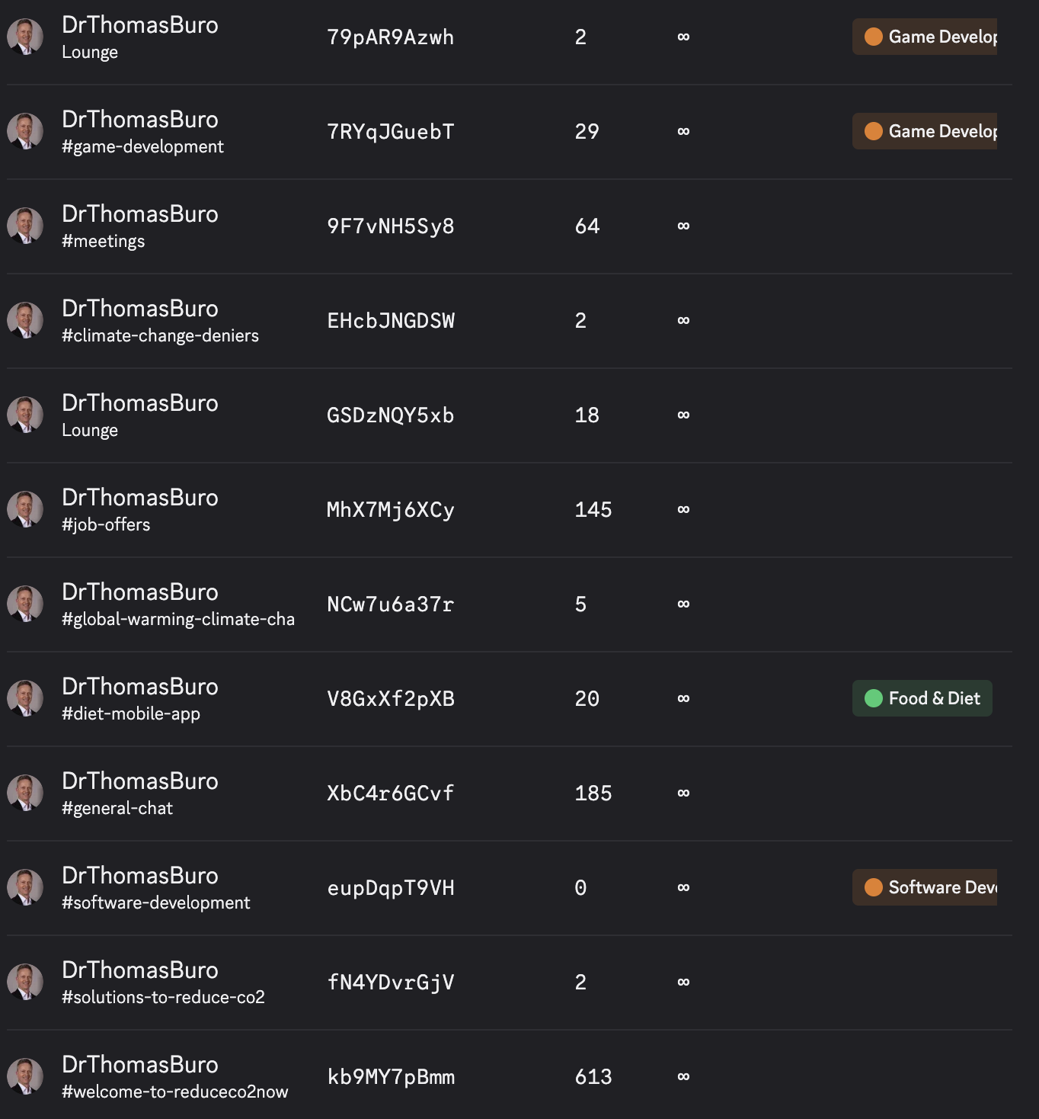

Job offer postings
So far >100 Job offers have been posted.
Here are some of the links for the oldest job offers posted.
https://www.linkedin.com/hiring/jobs/4417482143/detail/ user experience designer
https://www.linkedin.com/hiring/jobs/4417066370/detail/ user interface designer
https://www.linkedin.com/hiring/jobs/4416493611/detail/ ui ux designer
https://www.linkedin.com/jobs/view/4412009013/ Psychologist
https://www.linkedin.com/hiring/jobs/4410164659/detail/ SW dev Mobile App
https://www.linkedin.com/hiring/jobs/4411374266/detail/ Games SW dev
https://www.linkedin.com/hiring/jobs/4409264964/detail/ SM Creator
https://www.linkedin.com/hiring/jobs/4408466022/detail/ Social Media Manager
https://www.linkedin.com/hiring/jobs/4407271500/detail/ Social Media Content Creator
https://www.linkedin.com/hiring/jobs/4406798335/detail/ Team assistant
https://www.linkedin.com/hiring/jobs/4406480245/detail/ Software / Game Developer
https://www.linkedin.com/hiring/jobs/4405551343/detail/ Game Software Developer
https://www.linkedin.com/hiring/jobs/4405124668/detail/ User Experience Designer
https://www.linkedin.com/hiring/jobs/4404669610/detail/ Software Engieneer
https://www.linkedin.com/hiring/jobs/4404170051/detail/ Software Developer
https://www.linkedin.com/hiring/jobs/4403222201/detail/ SMManager
https://www.linkedin.com/hiring/jobs/4400822676/detail/ Minecraft Game
https://www.linkedin.com/jobs/view/4397564308/ UI UX game design
https://www.linkedin.com/jobs/view/4394171245/ Game Developer
https://www.linkedin.com/hiring/jobs/4389686367/ Minecraft Gamer
https://www.linkedin.com/hiring/jobs/4386159726/detail/ Video Designer
https://www.linkedin.com/hiring/jobs/4385044128/detail/ Minecraft Developer
https://www.linkedin.com/hiring/jobs/4364777460/detail/ Game Developer
https://www.linkedin.com/hiring/jobs/4356242109/detail/ Content Creator
https://www.linkedin.com/hiring/jobs/4365275425/detail/ Video
https://www.linkedin.com/hiring/jobs/4364066379/detail/ Internship
https://www.linkedin.com/hiring/jobs/4360622366/detail/ Author Editor
https://www.linkedin.com/hiring/jobs/4360641035/detail/ SM Discord
https://www.linkedin.com/hiring/jobs/4349348028/detail/ Commentator
https://www.linkedin.com/hiring/jobs/4346215615/detail/ Video Creator
https://www.linkedin.com/hiring/jobs/4345623965/detail/ Networker
https://www.linkedin.com/jobs/view/4342629089/ channel manager
https://www.linkedin.com/hiring/jobs/4324592258/detail/ Video Creator
https://www.linkedin.com/hiring/jobs/4323509202/detail/ Content Creator
https://www.linkedin.com/hiring/jobs/4323361023/detail/ Author
https://www.linkedin.com/hiring/jobs/4322880780/detail/ Team lead
https://www.linkedin.com/hiring/jobs/4322158434/detail/ webpage Wordpress
https://www.linkedin.com/hiring/jobs/4321815582/detail/ Social media Instagram
https://www.linkedin.com/hiring/jobs/4321157282/detail/ Project Manager
https://www.linkedin.com/hiring/jobs/4320971672/detail/ Dietitian
https://www.linkedin.com/hiring/jobs/4320118412/detail/ Team leader SM
https://www.linkedin.com/hiring/jobs/4319386316/detail/ Excecutive Assistant
https://www.linkedin.com/hiring/jobs/4318894003/detail/ Facebook
https://www.linkedin.com/hiring/jobs/4318384858/detail/ twitter
https://www.linkedin.com/hiring/jobs/4316198811/detail/ SMCC
https://www.linkedin.com/hiring/jobs/4316353595/detail/ VCD
https://www.linkedin.com/hiring/jobs/4313733740/detail/ reddit
https://www.linkedin.com/hiring/jobs/4313573690/detail/ TA
https://www.linkedin.com/hiring/jobs/4310358036/detail/ SMCC
https://www.linkedin.com/hiring/jobs/4307656964/detail/ SMCC G
https://www.linkedin.com/hiring/jobs/4305442643/detail/ HRBP
https://www.linkedin.com/hiring/jobs/4303681173/detail/ graphic design
https://www.linkedin.com/hiring/jobs/4303174624/detail/ app developer
https://www.linkedin.com/hiring/jobs/4301954765/detail/ Channel Manager
https://www.linkedin.com/hiring/jobs/4300720704/detail/ Media
https://www.linkedin.com/hiring/jobs/4297136451/detail/ Assistant
https://www.linkedin.com/hiring/jobs/4293502540/detail/ Diet
https://www.linkedin.com/hiring/jobs/4291567024/detail/ Finance
https://www.linkedin.com/jobs/view/4289457180/
https://www.linkedin.com/hiring/jobs/4286440983/detail/
https://www.linkedin.com/hiring/jobs/4281808272/detail/
https://www.linkedin.com/hiring/jobs/4277909828/detail/
https://www.linkedin.com/hiring/jobs/4272415540/detail/
https://www.linkedin.com/hiring/jobs/4269450287/detail/
https://www.linkedin.com/hiring/jobs/4259999281/detail/
https://www.linkedin.com/jobs/view/4250514101/
https://www.linkedin.com/hiring/jobs/4237647012/detail/
https://www.linkedin.com/hiring/jobs/4081568894/detail
https://www.linkedin.com/hiring/jobs/4081527844/

